**NETWORK ARCHITECTURE – 1**

**SOCKET PROGRAMMING – WEB SERVER**

**PROJECT – 1**

**Members:**

Seetha Rama Pradyumna Doddala (16201758)

Guru Teja Mannava (18129251)

Sai Bharath Attaluri (16199397)

**WEBSERVER CODE:**

|  |
| --- |
| **import** socket  __author__ = **'pradyumnad'  from** socket **import** * **import** re **import** os  PORT = 12345  **def** getrequestdata(data):  string = bytes.decode(data)  requestdata = {}  list = string.split(**' '**)  request_method = list[0]  requestdata[**"Method"**] = request_method  m = re.search(**"[a-zA-Z0-9_]*(.html|.htm|.gif|.jpg|.png)"**, list[1])   requestdata[**"FileName"**] = **"" if** m **is** None **else** m.group(0)  requestdata[**"File"**] = list[1].strip(**"/"**)  **return** requestdata  **if** __name__ == **'__main__'**:  serverSocket = socket(AF_INET, SOCK_STREAM)  host = gethostname()  info = getaddrinfo(host, PORT)  **print**(info)  serverSocket.bind((host, PORT))  serverSocket.listen(5)   **while** True:  **print**(**"Ready to serve."**)  client, address = serverSocket.accept()  **print**(**"Connection from "**, address)   **try**:  data = client.recv(1024)  string = bytes.decode(data)  **print**(string)  *# Request decoding* reqdata = getrequestdata(data)  **print**(reqdata)   filename = reqdata[**"File"**]  **print**(**"Opening "**+filename)   **if** len(filename) == 0:  filename = **"HelloWorld.html"   if** os.path.isfile(filename):  f = open(filename)  **print "file exist at this time"** client.send(f.read())  **print**(**"HTML sent to Client."**)  **else**:  filename = **"404Error.html"  print**(**"Opening "**+filename)  f = open(filename)  client.send(f.read())   **except** IOError:  **print**(**"Exception."**)  client.send(**"HTTP/1.1 404, File not found.\n"**)   client.close()  *# serverSocket.close()* |

**WEBCLIENT CODE:**

|  |
| --- |
| __author__ = **'pradyumnad'  import** socket **import** sys  **if** __name__ == **'__main__'**:  **if** len(sys.argv) > 1:  **print 'Number of arguments:'**, len(sys.argv), **'arguments.'  print 'Argument List:'**, str(sys.argv)  **else**:  **print**(**"Usage:"**)  **print**(**"python client.py server_host server_port filename"**)   s = socket.socket()  host = socket.gethostbyaddr(sys.argv[1])[0]  port = int(sys.argv[2])  filename = sys.argv[3]   s.connect((host, port))  request_data = **"GET /"**+filename+**" HTTP/1.1\n"**+\  **"Host: "**+sys.argv[1]+**":"**+str(port)+**"\n"**+\  **"Connection: keep-alive\n"**+\  **"Accept: text/html,application/xhtml+xml,application/xml;q=0.9,image/webp,*/*;q=0.8\n"**+\  **"User-Agent: Python Client\n"**+\  **"Accept-Encoding: gzip, deflate, sdch\n"**+\  **"Accept-Language: en-US,en;q=0.8\n"** s.send(request_data)   data = s.recv(1024)  **while** len(data) > 0:  **print**(data)  data = s.recv(1024)  s.close() |

**Steps:**

1. Install Python 2.7 version and Pycharm new version in your system.
2. Open a new project in Pycharm.
3. Create server.py and client.py in the project.
4. Add all the html files to the project(author,about_kc,committee,index,paper,program,registration,sponsor,technical,travel,tutorial).
5. Run the server code.
6. Open the Web browser and enter the URL in this format IP: Port number/filename.html.

Example: Server IP is = 10.151.1.171

Port number is 12345

**Optional Exercise:**

1. Instead of using a browser we can run the Client code in the terminal as shown below.

Navigate to folder myserver and execute the following command

**python client.py server_host server_port filename**

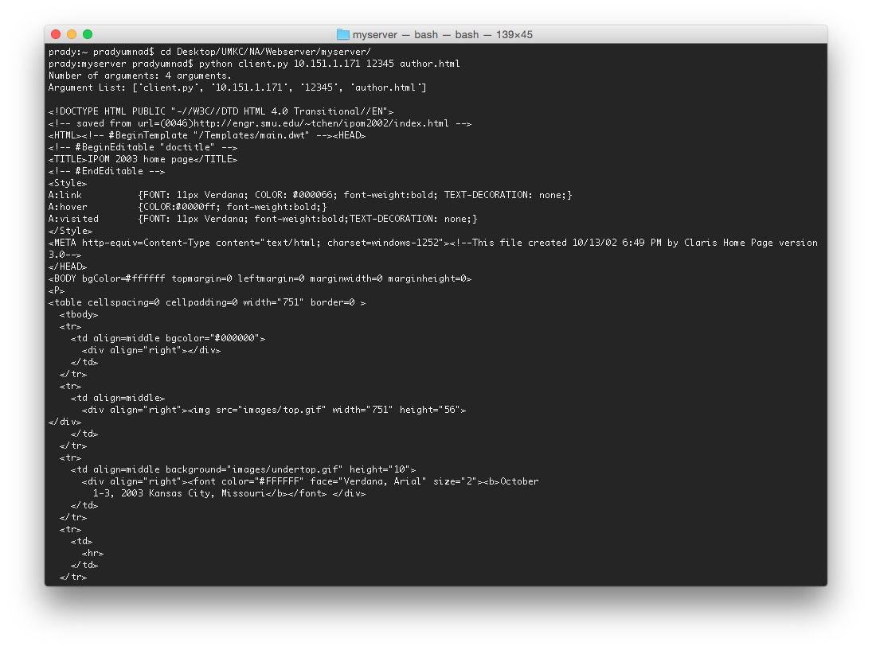

**Screen Shots:**

1. By using Server IP 10.151.1.171, Port number 12345 and without any file name specified. (By default it takes ‘HelloWorld.html’ as the base page).

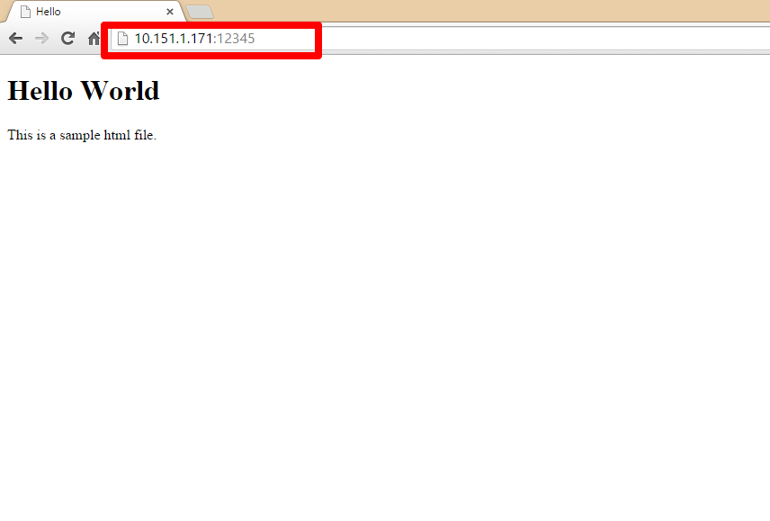

2. By using Server IP 10.151.1.171, Port number as 12345, but using invalid file name (**file which is not in the directory**)

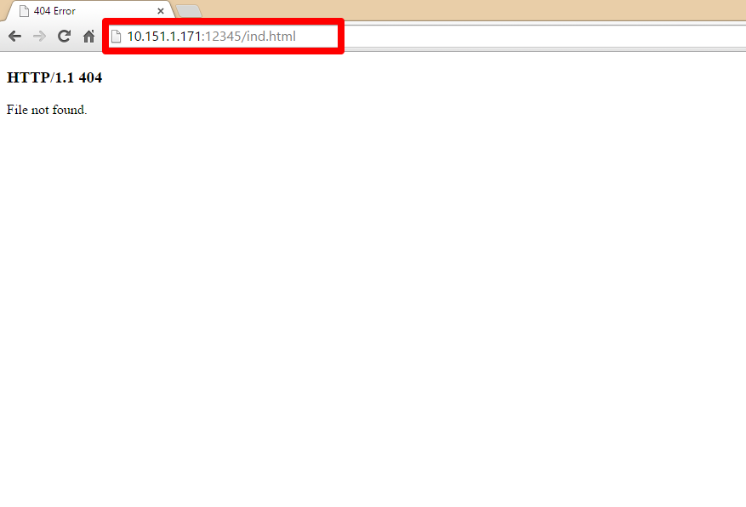

3. By using Server IP 10.151.1.171, Port number as 12345 and file name as author.html.

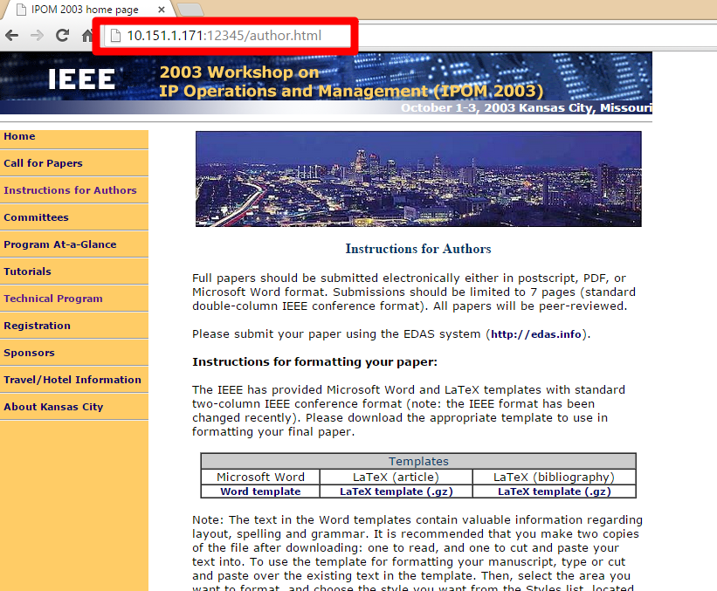

4. By using Server IP 10.151.1.171, Port number as 12345 and file name as committee.html.

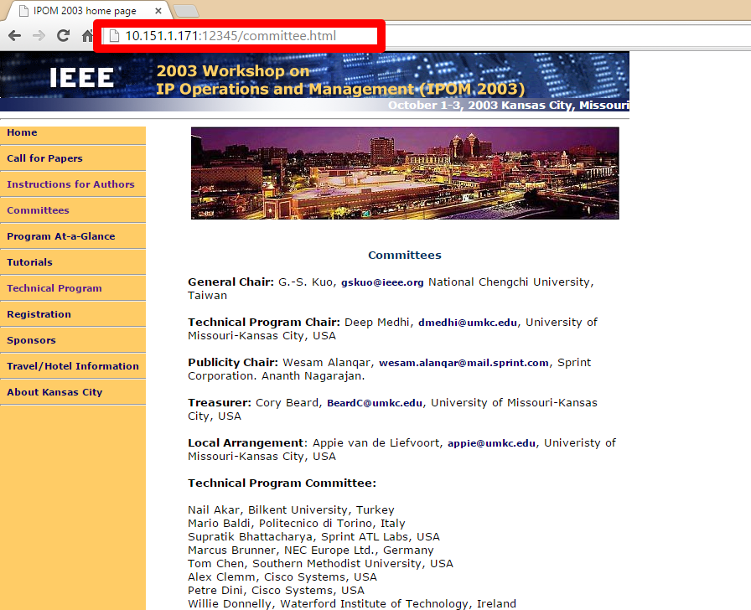

5. By using Server IP 10.151.1.171, Port number as 12345 and file name as paper.html.

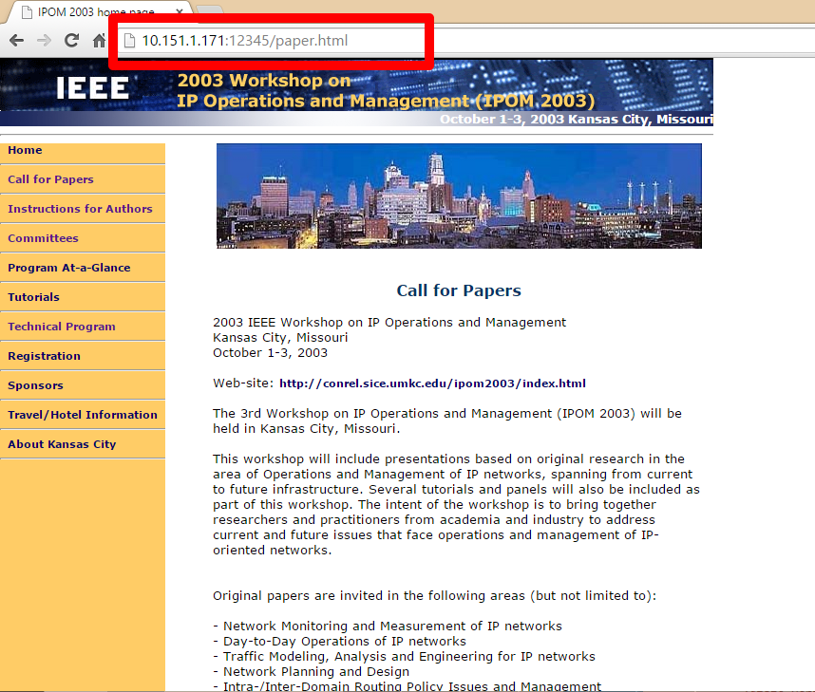

6. By using Server IP 10.151.1.171, Port number as 12345 and file name as program.html.

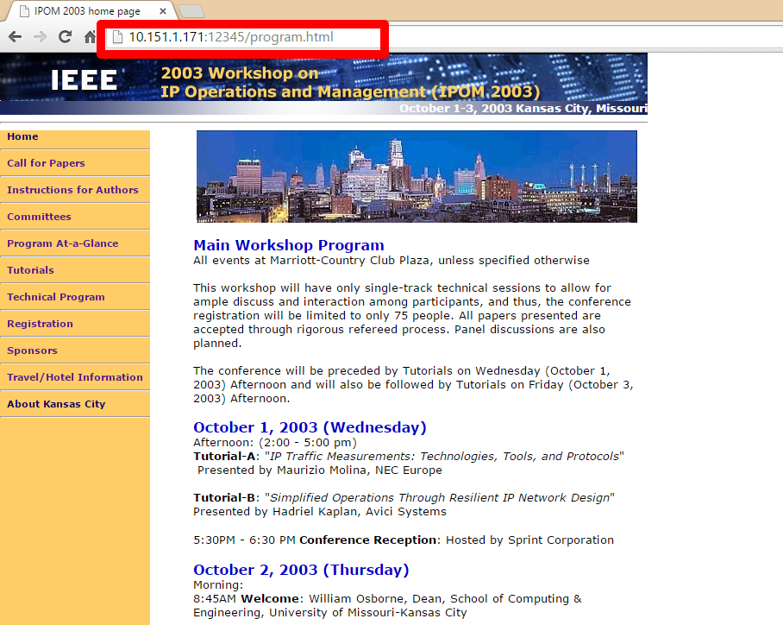

7. By using Server IP 10.151.1.171, Port number as 12345 and file name as index.html.

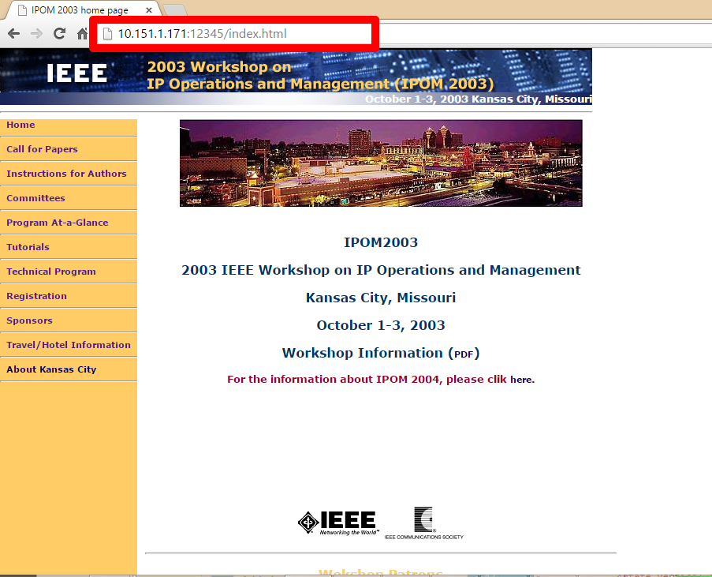

8. By using Server IP 10.151.1.171, Port number as 12345 and file name as registration.html.

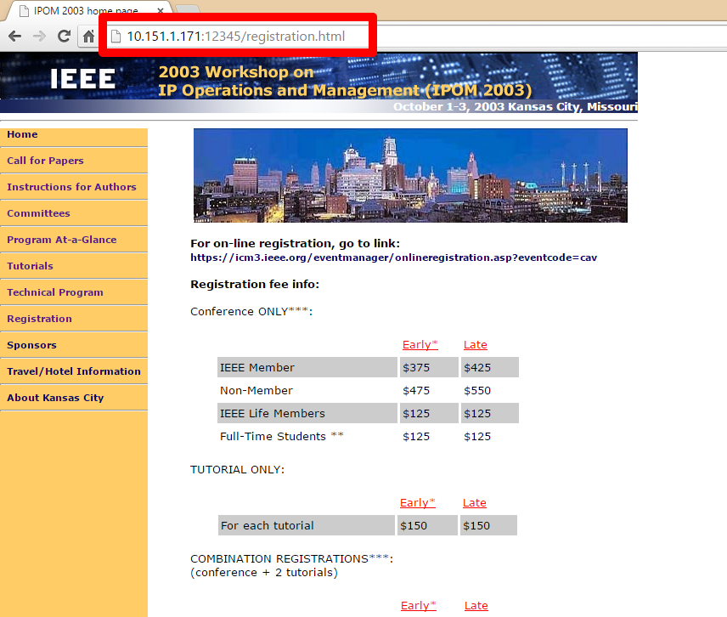

9. By using Server IP 10.151.1.171, Port number as 12345 and file name as sponsor.html.

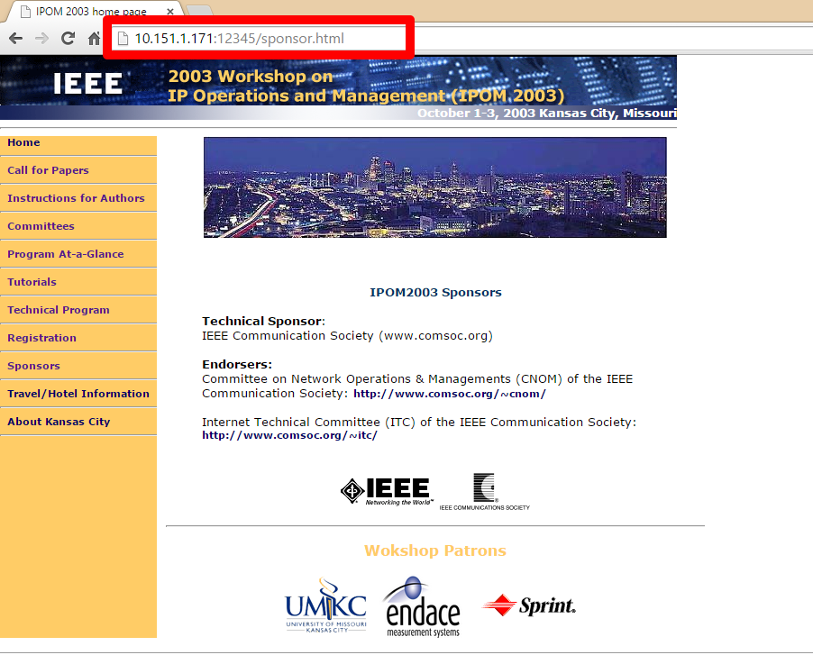

10. By using Server IP 10.151.1.171, Port number as 12345 and file name as technical.html.

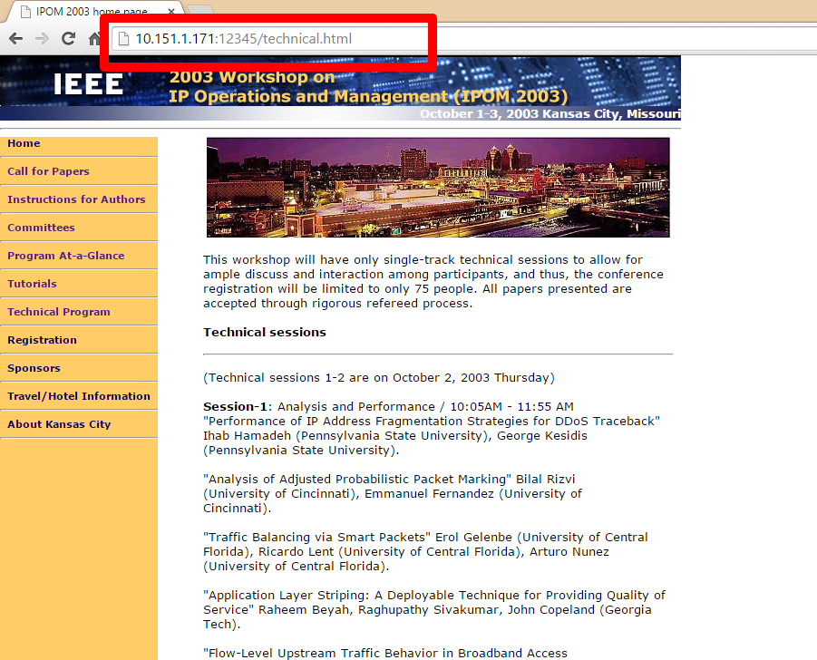

11. By using Server IP 10.151.1.171, Port number as 12345 and file name as travel.html.

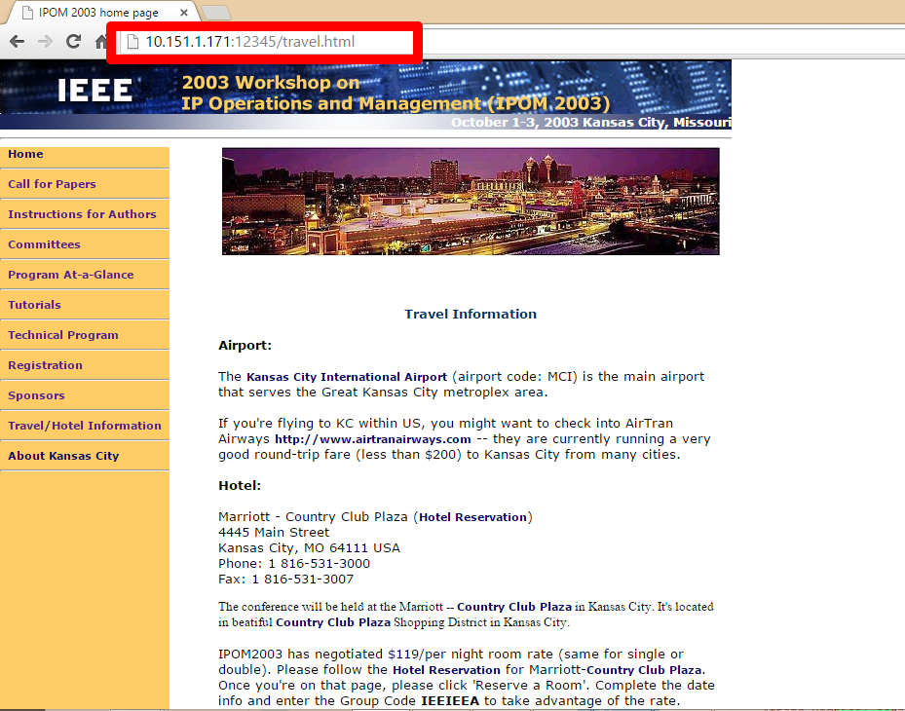

12. By using Server IP 10.151.1.171, Port number as 12345 and file name as tutorial.html.

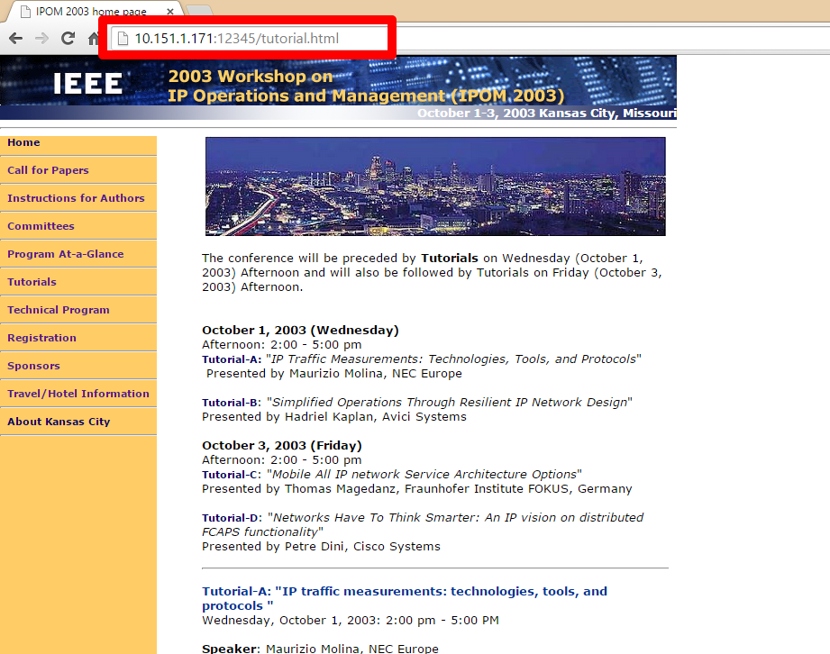

**References:**

<https://docs.python.org/2/library/socket.html>

<https://www.python.org/download/releases/2.7/>

<https://www.jetbrains.com/pycharm/download/>

**Signed Academic Dishonesty Policy:**

